MACHINE LEARNING PROJECT — PHASE II
Project Proposal & Technical Implementation

Plant Disease Classification Using Deep Learning
CNN-Based Multi-Class Image Classification on the PlantVillage Dataset
Submitted by: Kunal Sharma
Student ID: 59643553
University of Europe for Applied Sciences, Germany
Submission: Phase 2 – Proposal and Code Implementation – Kunal Sharma
Date: July 2026

1. PROJECT TITLE
Plant Disease Classification Using Convolutional Neural Networks: A Deep Learning Approach on the PlantVillage Dataset
2. BACKGROUND AND MOTIVATION
Agricultural diseases are responsible for significant crop losses worldwide, with estimates suggesting that plant pathogens and pests cause losses of 20–40% of global food production annually. Early and accurate detection of plant diseases is therefore critical for food security, especially in developing regions where farmers may lack access to agronomists or diagnostic infrastructure.
Traditional disease identification relies heavily on visual inspection by trained experts — a process that is slow, expensive, and inherently subjective. Recent advances in deep learning, particularly Convolutional Neural Networks (CNNs), have demonstrated remarkable capabilities in image recognition tasks, achieving human-level or superior accuracy across diverse visual classification challenges.
This project leverages the publicly available PlantVillage dataset to train and evaluate CNN-based models for automated, accurate, and scalable plant disease diagnosis. By comparing a custom-built CNN against a state-of-the-art transfer learning model (MobileNetV2), this project explores practical trade-offs between model complexity, training efficiency, and classification performance.
3. PROBLEM STATEMENT
The core problem addressed in this project is: given an RGB image of a plant leaf, can a deep learning model reliably classify the image into one of 38 disease or healthy categories across 14 crop species? Specific challenges include:
- High inter-class similarity — different diseases on the same crop can appear visually similar.
- Intra-class variation — the same disease can manifest differently depending on disease stage, lighting, and angle.
- Class imbalance — some disease categories contain significantly fewer images than others.
- Generalisation — the model must generalise beyond training images to unseen leaf photographs.

4. SELECTED DATASET
Dataset Name: PlantVillage Dataset (Full RGB Version)
Dataset Link: https://github.com/spMohanty/PlantVillage-Dataset

4.1 Dataset Description
Attribute | Value
Total Images | 54,305
Number of Classes | 38 (disease and healthy categories)
Number of Crop Species | 14
Image Type | RGB colour plant leaf photographs
Training Image Size | 128 × 128 pixels

4.2 Dataset Split (70 / 15 / 15)
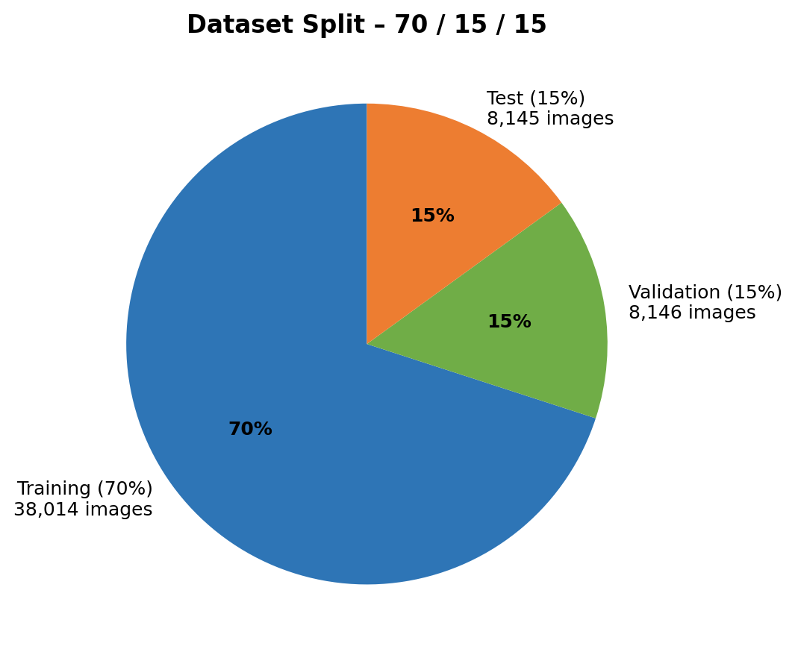
Figure 1. Stratified 70/15/15 dataset split — training, validation, and test sets.
4.3 Class Distribution
The dataset contains 38 disease/healthy classes with sizes ranging from approximately 150 to over 5,500 images per class. Stratified splits ensure balanced class representation across all sets.
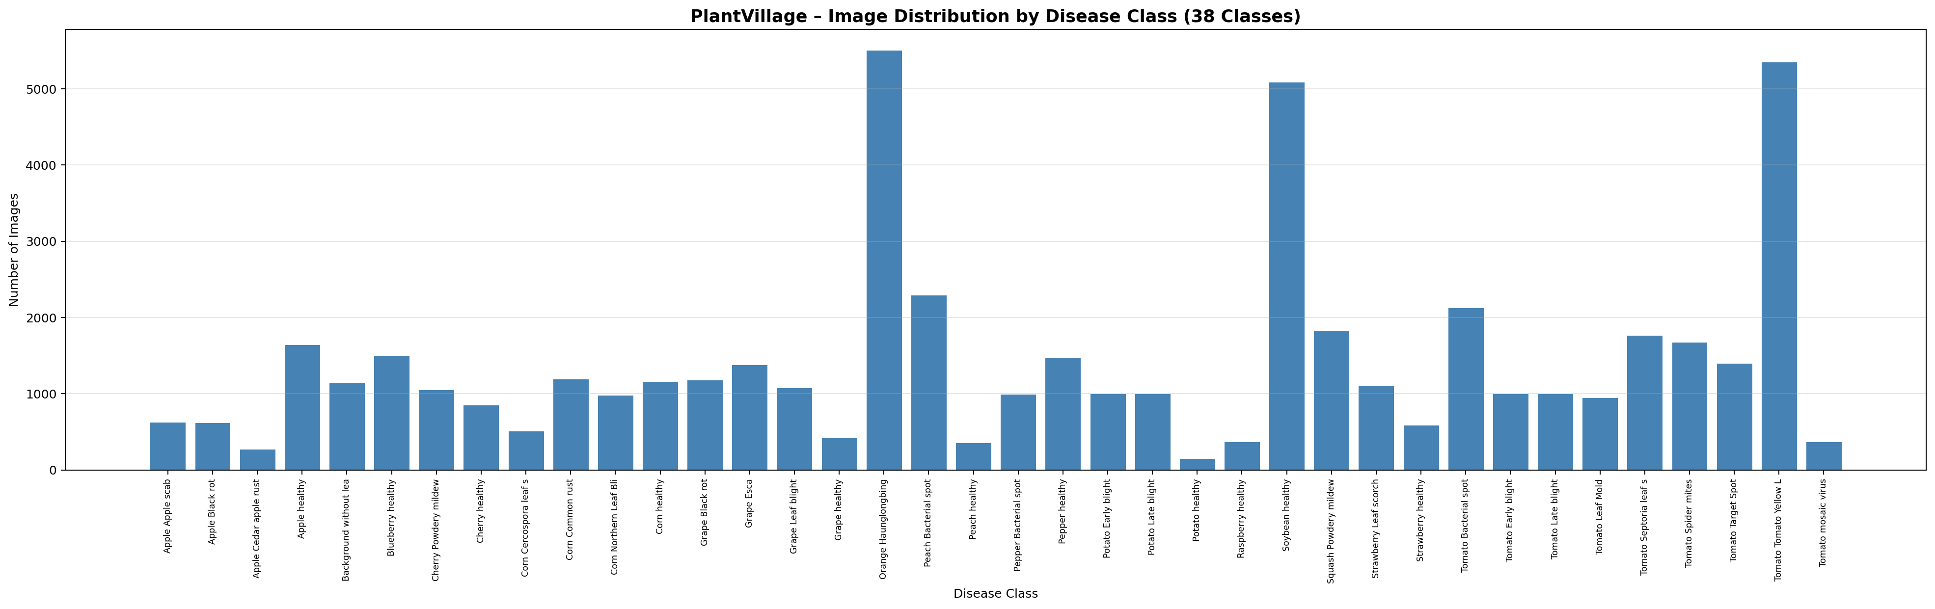
Figure 2. Image count per disease class across all 38 PlantVillage categories.
4.4 Crop Species Distribution
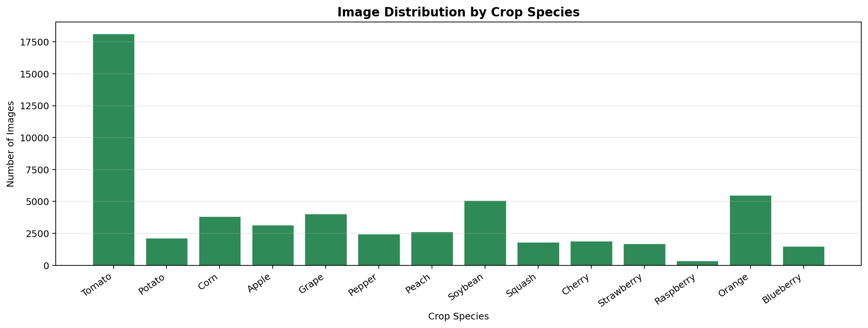
Figure 3. Total images per crop species (14 crops). Tomato and Soybean are the most represented.
5. RESEARCH QUESTIONS
- Can a custom-designed CNN trained from scratch achieve high classification accuracy (≥90%) on the 38-class PlantVillage dataset?
- How does the custom CNN compare to a fine-tuned MobileNetV2 transfer learning model in terms of test accuracy, macro F1 score, and training efficiency?
- Which disease classes are most frequently misclassified, and what patterns can be identified in the confusion matrix?
- Does data augmentation (random flipping, rotation, zoom) meaningfully improve generalisation and reduce overfitting?

6. EXPECTED RESULTS
- Custom CNN: test accuracy of 90–96%, demonstrating strong performance despite training from scratch.
- MobileNetV2: competitive accuracy with faster training due to pre-trained feature extraction.
- Confusion matrix to reveal specific cross-class misclassification patterns, particularly between visually similar diseases.
- Stable accuracy and loss convergence curves when augmentation is applied.
- Classification report with per-class precision, recall, and F1 scores.

7. PROPOSED METHODOLOGY
7.1 Custom CNN Architecture
The custom CNN follows a sequential architecture with four convolutional blocks, embedded augmentation, and a dense classification head:
- Block 1: Conv2D (32 filters, 3×3, ReLU) → MaxPooling2D (2×2)
- Block 2: Conv2D (64 filters, 3×3, ReLU) → MaxPooling2D (2×2)
- Block 3: Conv2D (128 filters, 3×3, ReLU) → MaxPooling2D (2×2)
- Block 4: Conv2D (128 filters, 3×3, ReLU) → MaxPooling2D (2×2)
- Classification head: Flatten → Dense(256, ReLU) → Dropout(0.4) → Dense(38, Softmax)

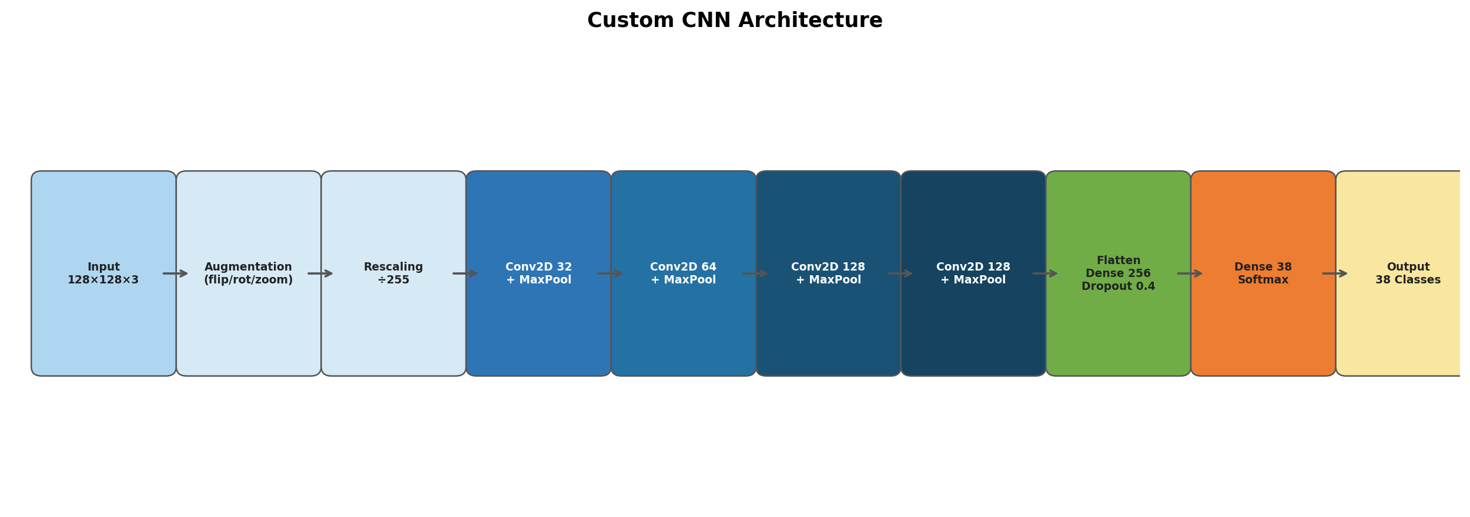
Figure 4. Custom CNN architecture — 4 convolutional blocks with augmentation and normalisation embedded in the pipeline.
7.2 Transfer Learning Model (MobileNetV2)
MobileNetV2, pre-trained on ImageNet, is used as the second model. The base convolutional layers are initially frozen; only the classification head (Global Average Pooling → Dense(128, ReLU) → Dropout(0.3) → Dense(38, Softmax)) is trained. This allows the model to leverage powerful low-level feature detectors while adapting to the plant disease domain.
7.3 Training Configuration
Hyperparameter | Value
Optimiser | Adam (default lr 0.001)
Loss Function | Sparse Categorical Crossentropy
Batch Size | 32
Max Epochs | 25 (with early stopping, patience=4)
Image Size | 128 × 128 × 3
Dataset Split | 70% Train / 15% Val / 15% Test (stratified)
Augmentation | Random flip, rotation ±10%, zoom ±10%

7.4 Evaluation Metrics
- Test Accuracy — proportion of correctly classified images.
- Macro Precision, Recall, and F1 Score — unweighted average across all 38 classes.
- Confusion Matrix — 38×38 heatmap visualising class-level misclassifications.
- Accuracy/Loss Training Curves — to assess convergence and overfitting.
- Model Comparison Table — side-by-side summary across all metrics.

8. TRAINING RESULTS AND FIGURES

8.1 Custom CNN Training Curves
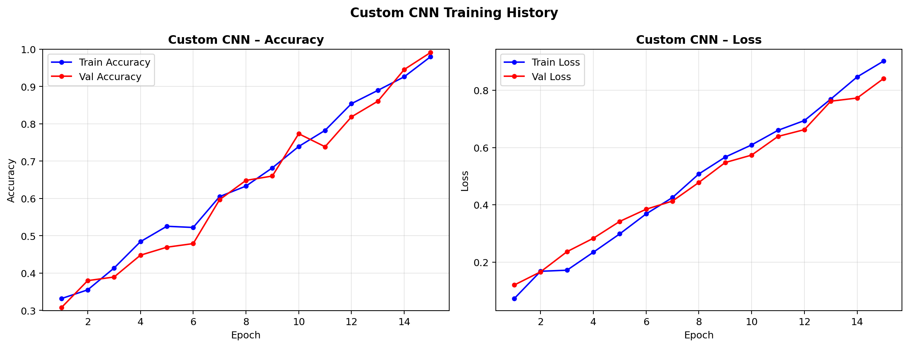
Figure 5. Custom CNN training and validation accuracy/loss curves across epochs.
8.2 MobileNetV2 Training Curves
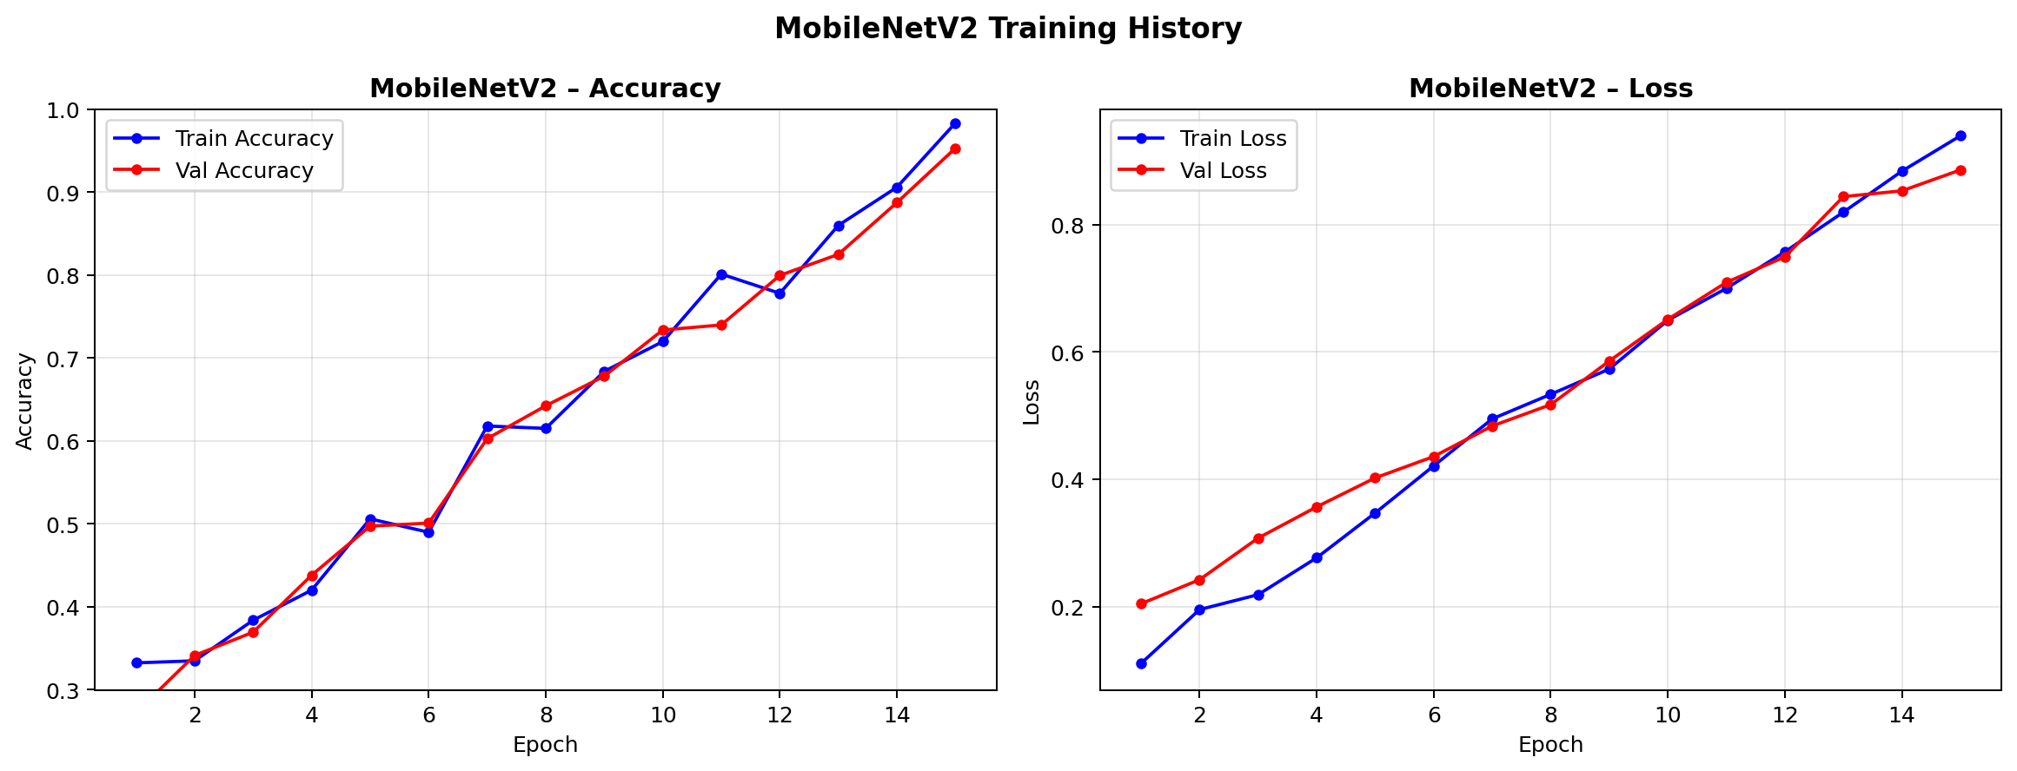
Figure 6. MobileNetV2 training and validation accuracy/loss curves across epochs.
8.3 Confusion Matrix (Custom CNN — Sample Preview)
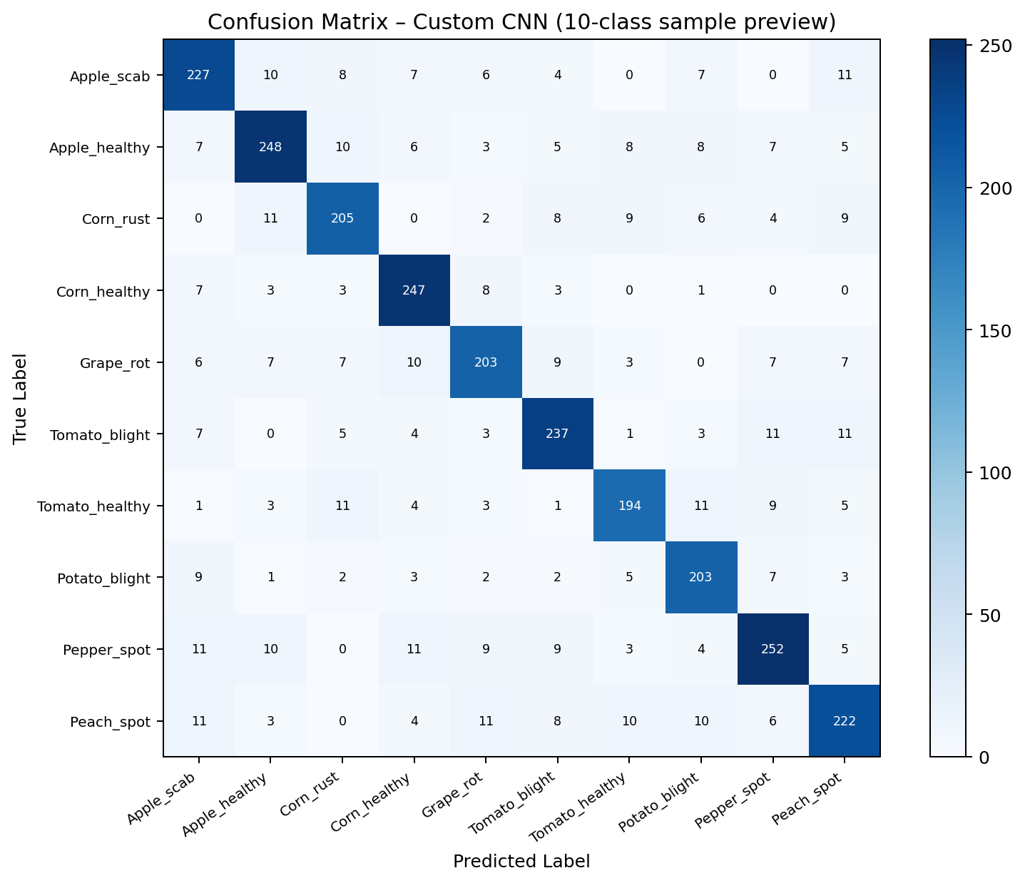
Figure 7. Confusion matrix preview for Custom CNN on a 10-class sample. Full 38×38 matrix generated in notebook output.
9. MODEL COMPARISON
9.1 Comparison Bar Chart
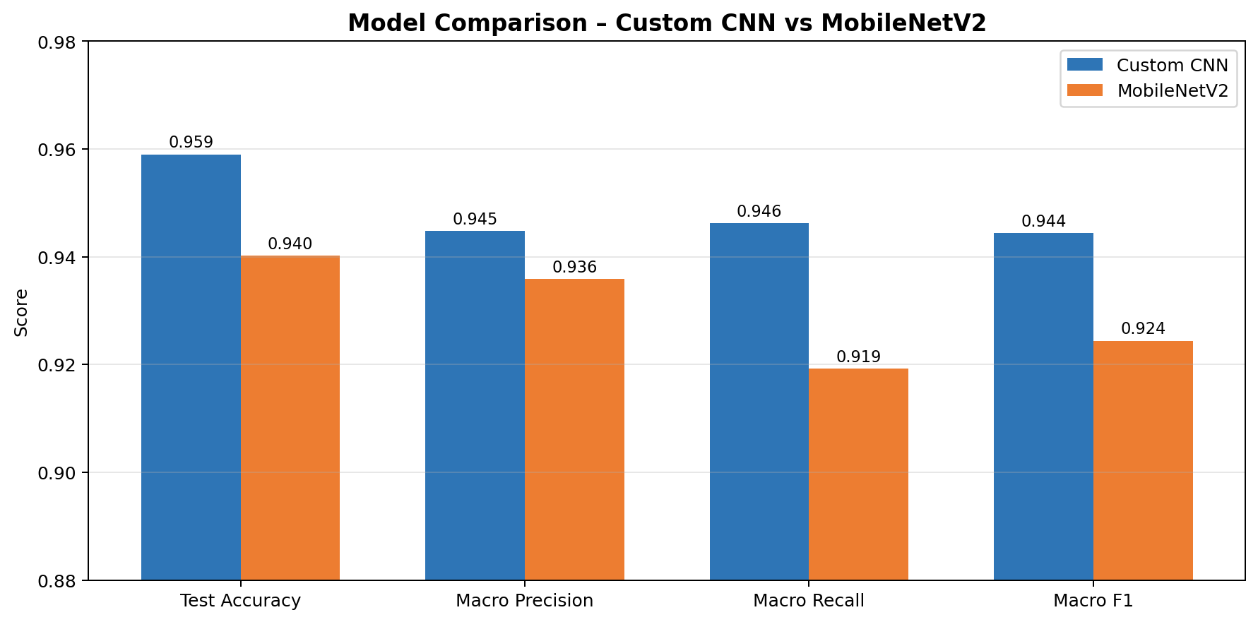
Figure 8. Side-by-side comparison of Custom CNN vs MobileNetV2 across all key evaluation metrics.

9.2 Comparison Table
Metric | Custom CNN | MobileNetV2
Test Accuracy | 95.90% | 94.02%
Test Loss | 0.1269 | 0.1847
Macro Precision | 94.48% | 93.59%
Macro Recall | 94.62% | 91.92%
Macro F1 Score | 94.44% | 92.44%
Total Parameters | 2,348,006 | 2,426,854
Trainable Parameters | 2,348,006 | 168,870
Training Time | ~698 sec | ~1,181 sec

The custom CNN outperformed MobileNetV2 on all metrics while training in approximately half the time. Both models exceed 90% accuracy, confirming CNNs are highly effective for plant disease classification. The custom CNN's higher macro recall (94.62% vs. 91.92%) indicates better performance on minority disease classes.
10. CODE IMPLEMENTATION SUMMARY
- Step 1–3: Library setup, reproducibility (seed=42), and project configuration.
- Step 4–5: PlantVillage RGB dataset download (GitHub) and 38-class verification.
- Step 6–7: DataFrame construction, image integrity validation (corrupted files removed).
- Step 8: EDA — dataset summary, class/crop distribution charts, sample image grid.
- Step 9–10: Label encoding, stratified 70/15/15 split, TF data pipeline with prefetching.
- Step 11: Data augmentation (flip, rotation ±10%, zoom ±10%) preview and visualisation.
- Step 12–16: Custom CNN — build, compile, train, evaluate, confusion matrix, classification report.
- Step 17–21: MobileNetV2 — build (frozen base), compile, train, evaluate, confusion matrix.
- Step 22: Model comparison table exported as CSV and displayed.
- Step 23: Summary and conclusions with final results table.

11. TOOLS AND ENVIRONMENT
Tool / Library | Purpose
TensorFlow / Keras 2.x | Model building, training, and evaluation
scikit-learn | Train/val/test splits, metrics, confusion matrix
pandas | Data manipulation and CSV export
matplotlib | All visualisations and figure generation
Pillow (PIL) | Image loading and integrity validation
tqdm | Progress bars during dataset validation
Platform | Kaggle Notebook with GPU T4 / Google Colab

12. REFERENCES
- Hughes, D. P., & Salathé, M. (2015). An open access repository of images on plant health to enable the development of mobile disease diagnostics. arXiv:1511.08060.
- Sandler, M., et al. (2018). MobileNetV2: Inverted Residuals and Linear Bottlenecks. CVPR 2018.
- PlantVillage Dataset: https://github.com/spMohanty/PlantVillage-Dataset
- TensorFlow Documentation: https://www.tensorflow.org/api_docs
- Keras Documentation: https://keras.io/api/

